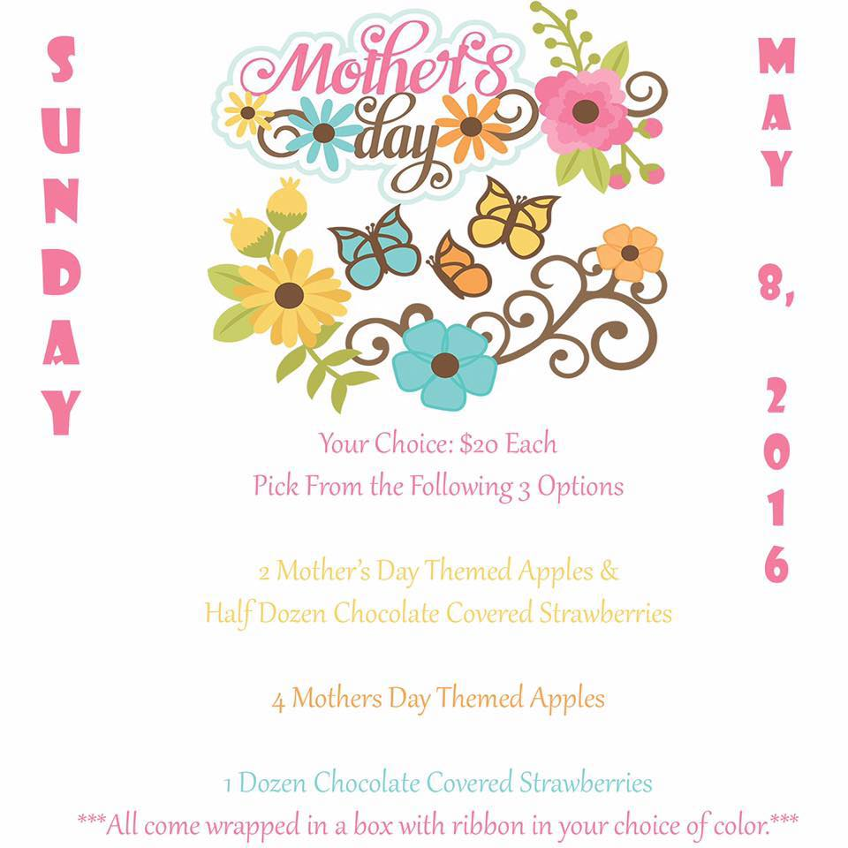

15% off all PROM orders placed in April 2016
10% off all PROM orders placed in May 2016
***Must Meet Minimum Order Requirement***

